Draw Hands like Albrecht Dürer- Art 2

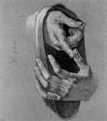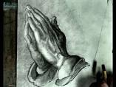
Who was Dürer? He was a painter, printmaker, and theorist of the German Renaissance. Born in Nuremberg, Dürer established his reputation and influence across Europe when he was still in his twenties due to his high-quality woodcut prints. He was also well known for his sketches, including the hands. His hand drawings beautifully capture lights and darks leading to a drawing with sense of depth and drama.
Big idea:
Drawing hands can be a challenge when you don't know what to look for. But when you know how to look for specific shapes, they are a lot easier to draw. Drawing hands, or anything else for that matter is as easy as drawing some simple shapes. Students will learn how to break down shapes in hands and how to use value to add drama like Dürer.

Skills: Drawing, Art History, Value study, perspective.

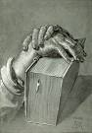
Schedule: 1 week

__________ Lesson discussion. Try drawing hand flat with details- contour line.

___________Draw hand pointing, fist, crossed fingers, or making a peace sign. You can work from a photograph (put in in a black and white filter. Draw it first in contour line using the tube method. When you are finished ask a friend what they think.

___________When your contour is satisfactory, show Ms C. and if she says so you can start to add value. Have at least 6 shades of value from white to black. Capture all the lines, etc.
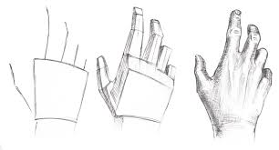

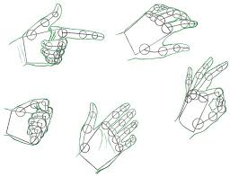
Rubric:
A- An A has good drawing that looks like the picture. There are 6 shades of value and lots of details! The student works hard throughout class and cleans up after themselves.
B- A B has at least 4 shades of value but seems a little flat in form and line work. The student works much of class but is frequently distracted with other things.
C- A C has only 3 shades of value, resembles a hand but really falls flat in effort. The student dabbles in class but wastes a lot of time and can leave messes behind.
D- Unfinished, very messy (lack of pride in work) or the student didn’t work much in class (lack of effort).

