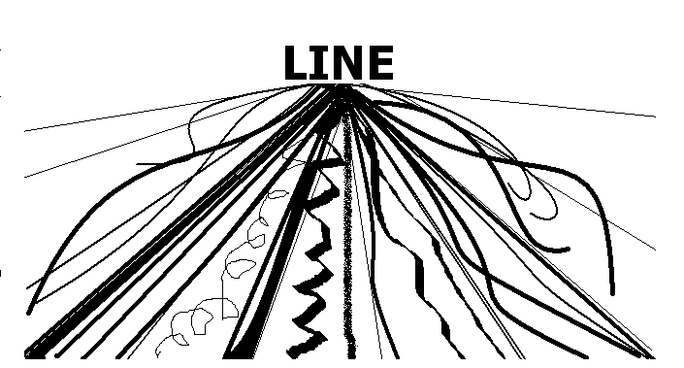

What is Line?
Line is most easily defined as a mark that spans a distance between two points (or the path of a moving point), taking any form along the way. As an art element, line pertains to the use of various marks, outlines and implied lines in artwork and design, most often used to define shape in two-dimensional work. Line is pretty much the building block for art in most cases. It can be expressive (Ex. Weight & Thickness) & Drawings that use a variety of lines are more sophisticated.

HOW WE USE LINE: TYPES OF LINES:
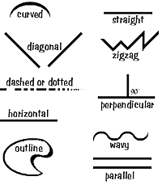
Assignment 1-Contour Line
Assignment 2- Draw the Line
Assignment 3- Cross contour
Assignment 4- Calligraphy
Assignment 5- Zentangle
Line Weight- How dark & thick a line is, will make it jump out from the paper (if it is a strong, dark line) or sink into the paper (if it is light or thin).
Contour Line:
the basic outline of an object

Closed contour:
Outlining an object through close observation without lifting your pencil

Gesture:
a quick sketch of the overall image Drawn in less than 30 seconds.

Cross contour:
When you use lines repeatedly to show the curve or flow of an object

Blind contour:
to draw through careful observation without lifting your pencil and without looking at your paper.

Signatory Line:
A more expressive form of drawing, in which, the artist allows the flow of line to carry feeling. Signatory line, like a signature, will be unique to the artist, the product of their individual hand and mind.

Calligraphy:
Decorative handwriting or handwritten lettering.

Zentangle:
Zen-like drawing process that incorporates line variety.

